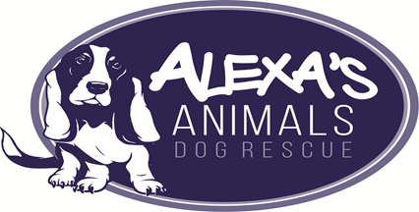

Animal Welfare

This policy outlines the views of Alexa’s Animals in relation to the care of dogs that come into its care.
All dogs coming into our care must be treated with respect and empathy.
Alexa’s Animals endeavour to take a 360 degree holistic approach by applying an understanding of their natural welfare needs as well as their emotional and biological needs.
All dogs will receive appropriate veterinary care in order that they are free from pain and discomfort.
All dogs will be provided with a safe, secure environment. If necessary, they will be housed with a companion.
Alexa’s Animals will always endeavour to source permanent, secure and loving homes.
Alexa’s Animals will provide advice, support and guidance for dog owners.
Alexa’s Animals will ensure that only those animals suffering an unacceptable quality of life as defined by the Animals Welfare Act (2006) are euthanised. The decision to euthanise will only be taken upon receiving advice from our Veterinarians.
Alexa’s Animals will not knowingly put the public or other animals at risk by rehoming animals considered as a potential threat to safety.
All decisions will be made in a timely fashion to ensure against prolonged physical or emotional suffering.
Alexa’s Animals will carry out an efficient and sensitive intake process in which the welfare of dogs takes priority.

All dogs brought into Alexa’s Animals will be neutered (applies to male and female dogs) unless it is not in the best interest of the dog and so advised by our Veterinarians. They will also receive all necessary vaccinations.

Change record

Date By whom Comments
22/08/2017 CLG Add final sentence in line
in line with our process.

Version 1.2 6/7/2016

