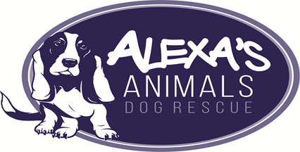
Registered Charity Number 1170022
Rehoming Process

To start the rehoming process have a look at our dogs available for adoption on our Facebook or web page.
When you think you have found a dog that is right for you contact us for a quick chat.
If after talking with us, you wish to go ahead with the first steps in the adoption process then we will be complete an adoption enquiry form.
If we think you are a good match for each other we will ask you to attend our kennels/foster home so that you can meet your possible new best friend.
If we think that you may not be the best match we will explain why and let you know of any other dogs we have available for rehoming and which may be a better fit for you and your family.
Depending on the dog you choose we may ask you to attend the kennels several times so that you can get to know each other. This may include taking the dog for walks etc. (please note we do require photo id and proof of address). This is also the time that you should bring any other dogs you have and any other family members with you to meet the new dog. We want to make sure everyone is happy with the decision.
Providing everyone is happy and you wish to continue to adopt your chosen dog, we will arrange to do a home visit. During this time the dog will be reserved so no one else will be able to adopt him/her. We may also ask you to take the dog home for a day to see how everyone interacts within a home environment.
If, after all this, you still want to adopt, then we will ask you to attend the kennels one last time to fill out all the necessary paperwork and pay the adoption fee. You may then take your new best friend home with you.
Please note that before your new dog leaves us he/she will be microchipped, vet checked, vaccinated, wormed and neutered/spayed (exceptions apply). Your fee only covers a small part of this expenditure so we believe you are getting good value for money.

